Created By Ashwini Kulkarni

* **Database Setup :-**

(Optional)For your own DB version

phpmyadmin-ctl install

DB setup has been done on shared clould9 account:

Link

https://acs567project-alhas01.c9users.io/phpmyadmin/

username:

alhas01

Passwd:

Database already has been created.

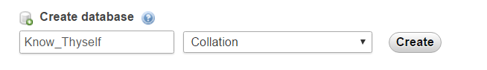

Currently only 12 questions are added in Database for MBTI test.

For DB Connection:

define("USER", " alhas01");

define("PASS", "");

define("DB", "Know_Thyself");

// connect to database

$connection = new mysqli('localhost', USER, PASS, DB);

* **Sample Queries:**

For getting data in php:-

1. **To fetch question and their options for MBTI test**

SELECT DQ. qusid, DT. Testid, DQ. qus_desc, OPT.op1, OPT.op2

From Dim_Question DQ

INNER JOIN Dim_Test DT ON DQ.testid= DT.testid

INNER JOIN Dim_Qus_Option OPT ON (DQ.testid=OPT.testid and DQ.qusid=OPT.qusid)

ORDER BY DQ. qusid;

1. **On Submit need to fire following queries from PHP side:**

Var X (it should be int type) = Select max(userid) from UserDetails;

New_user_id = X+1;

Insert into UserDetails (userid , created_date) values (New_user_id,NOW());

Commit;

Storing Ans:

Testid = select testid from Dim_Test where testname=’MBTI’;

Qusid: qusid received on loading questionaries

Ans: selected option

created_date:NOW()

Insert into Test_User_Ans(testid , userid , qusid , ans ,created_date ) values (……)

Commit;

1. **Result:**

**Currently it will not have result fetch. (Part of Sprint2)**